Building Maintenance Management System
Process Modeling and Data Modeling /
System Proposal / Analysis Phase
(Homework No.3)

Project team: Team 06
Instructor: Dr. Araz Yusubov

Submitted in partial fulfillment of the requirements of the INFT 2303: Systems Analysis and Design course project

GitHub repository | https://github.com/ADA-SITE-INFT2303-2023-Spring/sys-dev-project-team-06.git
Version date | Version information
22.04.2023 | Initial draft
<Date> | <Version description>

Other documents in the package
File name | Brief description of the document
<File name> | <Description of the document>
<File name> | <Description of the document>

Team member | Contribution to this homework (NOT the project) | Estimated %
Fahmin Mahili | <Description of the work contributed> | <X>%
Nijat Shirinov
Ayatay Kazimli
Latif Asgarov

Table of Contents
<Automatically generate here using Microsoft® Word menu References→Table of Contents>

Introduction
This is part of the System Proposal for a hypothetical project Building Maintenance Management System submitted for partial fulfillment of the requirements of the Systems Analysis and Design course in the School of Information Technologies and Engineering at ADA University, Baku, Azerbaijan.
The main purpose of this system is to provide a single platform for apartment owners to manage their maintenance and expense operations. The Building Maintenance Management System is designed with an easy-to-use interface, so apartment owners can manage their maintenance and expenses with ease.
This document covers process modeling, including DFD diagrams to generate a new system for implementation. It also covers data modeling and ERD (Entity Relationship Diagram) to show how data relates to each other, and how it can be useful for creating a relational database.

<DELETE each and every instructional paragraph between (and including) < and > everywhere in the document and REPLACE ALL of them with your text. Keep the main numbered sections, but feel free to add sub-sections if needed.

All consequent homework assignments will be based on this document, so give it enough thought.>

<Briefly describe the content of the document and work done to prepare it. This document must be submitted in original Microsoft© Word format.>

<While doing analysis and getting better understanding of the system you may need to make changes in the HOMEWORK No.1B/2 document, such as additions/modifications to product functions or use cases. In this case Homework No.1B/2 document should be submitted, too. Edits in these documents should be visible by turning the TRACK CHANGES option on through Review→Track Changes menu and version information on the title page should be updated.

Bonus 1: Get extra 15% points for revising and SUBSTANTIALLY improving the Homework 1/2 document.

All Microsoft© Word documents should be submitted as separate files. Any additional files of other types e.g. diagram and charts will usually be inserted to this document as embedded images, but the source files should also be submitted in a SINGLE .zip archive file.>
< Submit your assignment through the course website:
- Use your GitHub repository to keep all your project files and make sure all team members update it regularly. The teams are expected to submit their homework through Blackboard, at the same time their work must be traceable through the GitHub Classroom.
- Submit to the grader the following files before the deadline:
  - Process Modeling and Data Modeling (this document) as Microsoft© Word documents.
  - For Bonus 1, System Request and Feasibility Study (Homework No.1B) or/and Requirements Determination and Use Case Analysis (Homework No.2) as a Microsoft© Word document with tracked changes.
  - Any additional files of other types e.g. diagram and charts will usually be inserted to this document as embedded images or tables. At the same time, the source files e.g. Excel .xlsx files or Diagrams.Net .drawio files should also be submitted inside a single .ZIP archive file.
- Do not forget to inform your team mates, to avoid multiple submissions.
- You will be graded based on your contribution to the team submission, which is to be evaluated for its clarity, technical soundness, thoroughness and coverage, relevance and utilization of resources.
>

<This section is accounting for about 6% of your assignment grade.>

Definitions
<Every time you come across a project-specific term (which can be interpreted differently e.g. “terminal”), add a short description of it to the table below. Insert here any technical word for which the meaning may not be known. DO NOT assume that the readers have specialized knowledge. Use a table format for these.>

Term | Definition
<Term> | <Detailed term definition>

<This section is accounting for about 4% of your assignment grade.>

Process Modeling

Context Diagram:

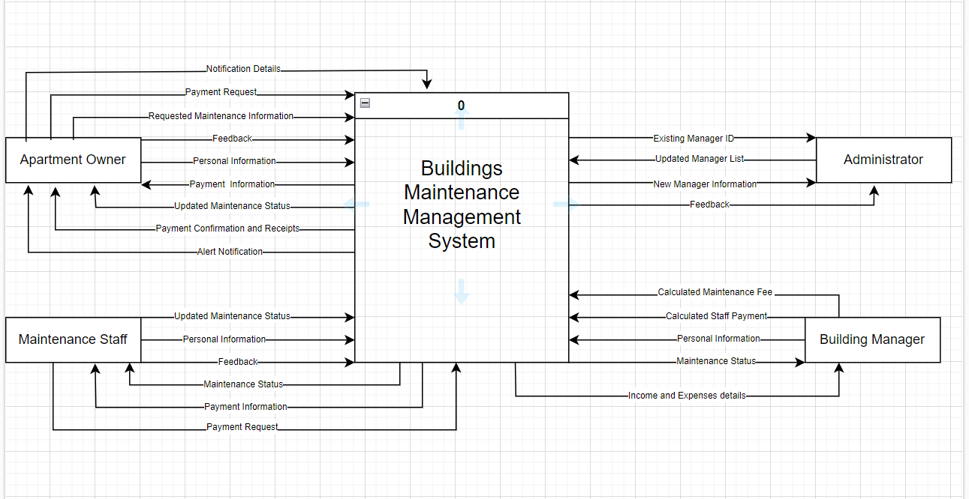

The context diagram of Building Maintenance Management System demonstrates how the main system process interacts with external entities, data flows, and exchanges information. The system method, "Building maintenance management system," is the most important part of the context diagram. This process is the central factor of the context diagram that happens and is done in the system. Moreover, there are 4 external actors which are Apartment Owner, Maintenance Staff, Building Managers, and Administrator that interact with the system process.
Apartment Owner uses the system for registering in the system, creating maintenance requests for the building, and making payments.
Maintenance Staff uses the system for registering in the system, managing maintenance requests and payment information.
Building Manager uses the system for registering in the system, calculating staff payment and maintenance fee based on income and expenses details.
Administrator uses the system for getting and managing all feedbacks from Apartment Owner, Maintenance Staff, and Building Manager, and updating building manager list such as adding, or removing.

Bonus 2: Get extra 10% points for complementing all process descriptions with UML activity diagrams. For the context-level diagram it must be in a form of a swim lane diagram.>

Level 0 diagram

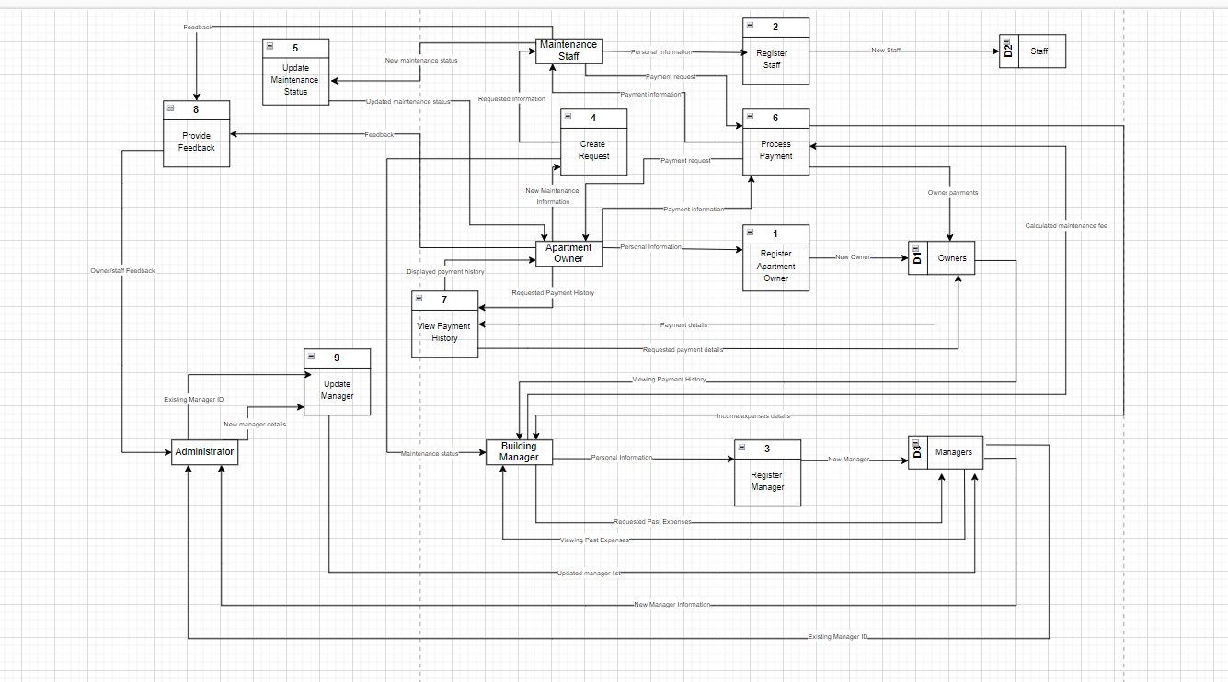

<This section is accounting for about 10% of your assignment grade, and the diagrams for about additional 20 %.>

Level 1 diagrams
<Bonus 3: To get extra 15% points draw also all Level 1 data flow diagrams. >

Data Modeling
<This section specifies the logical requirements for any information that is to be processed by system. Draw the UML entity relationship diagrams that will be useful here to show complex data relationships.

In this section list all entities with a brief description including all attributes explained. Indicate initial entities and those added later in the process of normalization e.g. intersection entities. Discuss the relationships, including their modality and cardinality.>

<This section is accounting for about 10% of your assignment grade, and the diagrams for about additional 15 %.>

CRUD matrix
<To balance process and data models draw your CRUD matrix in this sub-section. Use the processes from your data flow diagrams on the highest level of detail.>

<This section is accounting for about 10% of your assignment grade.>

References
<Insert here any document referred to in the document. An example might be articles or Web sites that you consulted during the literature search. This is not just a list of used materials, so do not forget to clearly MARK the exact points(s) of reference in the main text.

This can be done by adding endnotes at the exact points of reference in the main text.>

<This section is accounting for about 5% of your assignment grade.>

This template uses some materials by Rochester Institute of Technology Software Engineering Department.

